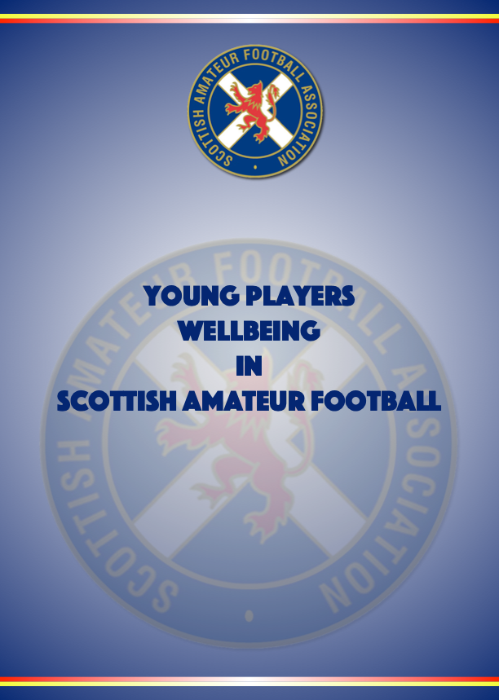
INSERT INTRODUCTION FROM THE CHIEF EXECUTIVE/NATIONAL SECRETARY/PRESIDENT OR EQUIVALENT HERE

CONTENTS

- Introduction - Page 3

1.1 Overarching aims - Page 3

1.2 Definitions - Page 3

1.3 Young People’s Wellbeing in Scotland - Page 5

1.4 Risks to Young People’s Wellbeing in Scottish Football - Page 6

1.5 Everyone’s Responsibility - Page 9

1.6 Review - Page 10

- Policy Statement - Page 11

- INTRODUCTION

  - Overarching Aim for Young Person Wellbeing and Protection in Scottish Football

Vision
Young People flourish because we put their safety, wellbeing, rights and enjoyment at the heart of every level of Scottish football.

Mission
Young People are the priority. We lead with confidence taking responsibility to create a culture of safety and wellbeing. We empower young people through active promotion of their rights.

  - Definitions

Definition of the Young Person Wellbeing and Protection Policy

Scottish Amateur Football Association’s Young Person Wellbeing and Protection Policy includes:

- Introduction – Overarching Aim, Definitions, Young People’s Wellbeing in Scotland, Risks to Young People’s Wellbeing in Scottish Football, Everyone’s Responsibility and Review
- Policy Statement
- Set the Standards – Behaviours, Expectations and Requirements
- Procedures – Appointment and Selection, Responding to Concerns and Case Review
- All associated Practice Notes

Herein all the documents listed above will be referred to as the ‘Young Person Wellbeing and Protection Policy’ or ‘this policy’.

Definition of Young Person

Article 1 of the United Nations Convention on the Rights of the Young Person states that everyone under 18 has the rights set out in the Convention. Within the Young People and Young People (Scotland) Act 2014, a Young Person is defined as anyone who has not reached the age of 18.

For the purpose of this policy, “Young Person” refer to persons under the age of 18.

The Young Person Wellbeing and Protection Policy applies to all young people and regardless of age, gender, sexual orientation, disability, race, religion, nationality, socio-economic status or family circumstance.

Definition of Adult

For the purpose of this policy an “adult” is any individual aged 18 and over or any individual under the age of 18 years old but who is in a ‘position of trust’.

Definition of Young Person Abuse

Young Person abuse is the act or omission that harms a Young Person.

An individual may abuse a Young Person directly, or may indirectly be responsible for abuse because they fail to prevent another person from harming that Young Person, or their inaction leads to harm or risk of harm. Abuse can be physical, emotional, sexual or by neglect. Abuse can take place in person or online. Although typically thought of as when an adult is mistreating a Young Person or , young people and can also be perpetrators of abuse against other young people or .

Definition of Safeguarding

Safeguarding is taking action to ensure that all young people and are safe from harm when involved in football. It means proactively doing everything possible to minimise risk and prevent abuse of young people and .

Definition of Young Person Protection

Young Person protection refers to the actions in response to a specific concern for a Young Person who is at risk or suffering from abuse. Young Person protection is an essential part of safeguarding if there is a concern that a Young Person is being abused or their safety is compromised.

  - Young People’s Wellbeing in Scotland

Getting It Right for Every Young Person

The Scottish Government’s Getting It Right for Every Young Person (GIRFEC) is based on young people’s rights, and its principles reflect the United Nations Convention on the Rights of the Young Person (UNCRC). The GIRFEC approach is Young Person focused, based on an understanding of the wellbeing of a Young Person in their current situation, and based on tackling needs early in a collective way. As part of the Young People and Young People (Scotland) Act 2014, the concept of wellbeing and the GIRFEC approach is now enshrined in law in Scotland.

The GIRFEC approach supports young people so that they can grow up feeling loved, safe and respected, and can realise their full potential. Young People and should be: Safe, Healthy, Achieving, Nurtured, Active, Respected, Responsible, Included. These are the eight wellbeing factors and are commonly known as SHANARRI Indicators.
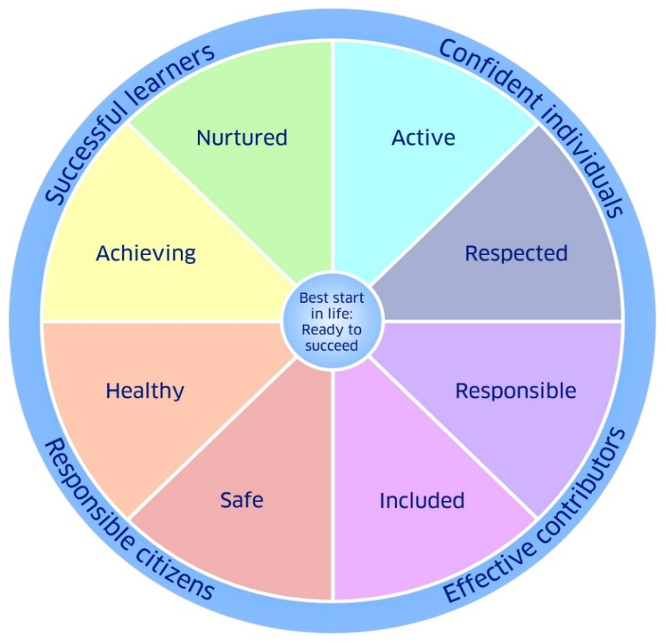

A Young Person wellbeing is influenced, both positively and negatively, by everything around them and the different experiences and needs they have at different times in their lives. There is no set level of wellbeing that a Young Person should achieve, but each Young Person should be helped to reach their full potential as an individual. The wellbeing indicators make it easier for everyone to be consistent in how they consider the quality of a Young Person or ’s life at a particular point in time.

By having a universal language and understanding for everyone who works with young people and , collectively we can contribute to promoting, supporting and safeguarding a Young Person’s wellbeing whether they are in an educational, health, community or sporting setting. It is essential that in Scottish football the wellbeing indicators are understood and if worried that something is impacting a Young Person or ’s wellbeing staff and volunteers know how to respond and with whom to share that information.

Wellbeing Concern

A wellbeing concern is if a Young Person’s wellbeing (measured using the 8 SHANARRI indicators) is, or is at risk of being, adversely affected.

A range of experiences can have a negative impact on young people. These can range from harmful or abusive behaviour to a family bereavement or social economic factors, such as poverty. The nature of a wellbeing concern will influence how to support the Young Person

Behaviour which is abusive or neglectful and is, or is likely to cause harm, will often be referred to as a ‘Young Person protection concern’. Regardless of whether a concern is a wellbeing or Young Person protection concern, it must be responded to in line with the Responding to Concerns Procedure.

1.4 Risks to Young People’s Wellbeing in Scottish Football

The protection and wellbeing of all young people involved in Scottish football must be a priority for everyone working, volunteering or participating in the game, including spectators. For young people involved in football there may be risks associated with their involvement whether it be injury, the despair of their team losing, or exposure to poor practice or abusive behaviour. It is essential that those working or volunteering with young people are alert to the associated risks and take steps to prevent, minimise or respond to the risks.

In addition to recognising risks to all young people , it is important to understand that some young people and may be more vulnerable to particular risks associated with taking part in football.

Increased vulnerability

Scottish Amateur Football Association is committed to ensuring the safety of all young people in football across all levels of the game. Young People who have additional care needs or who come from a minority ethnic group may face a range of additional challenges. Staff and volunteers will be encouraged and supported to challenge, and address any behaviour or attitudes which compromise a Young Person’s wellbeing, or acts as a deterrent to the participation of some young people.

Young People who are deaf and disabled

In line with Article 23 of the United Nations Convention on the Rights of the Young Person (UNCRC), a Young Person with a disability “should enjoy a full and decent life, in conditions which ensure dignity, promote self-reliance and facilitate the Young Person’s active participation in the community”.

Young People and who have a disability have the same needs as other young people and , but may also have additional needs associated with their disability. For example, additional steps may be needed to promote their wellbeing or they may be at an increased risk of abuse due to their vulnerability. Research has shown that young people with a mental or physical disability are more likely to be abused than non-disabled young people.

Young People who are deaf, disabled or have a learning disability can be additionally vulnerable because they may:

- Depend on a number of people for care and handling, some of which can be intimate care
- Depend on the abuser for their involvement in sport
- Fear disclosing abuse
- The signs of abuse can be misinterpreted as a symptom of the disability
- Have a reduced capacity to resist either verbally or physically
- Have significant communication differences – this may include very limited verbal communication, the use of sign language or other forms of non-verbal communication
- Lack a wide network of friends who support and protect them
- Lack access to peers to discover what is acceptable behaviour or to understand the inappropriateness of actions
- Not be believed due to negative attitudes towards young people and with disabilities or possible failure to recognise the impact of abuse on young people and with disabilities

Young People from black, asian and minority ethnic communities

The UNCRC sets out the general principle of non-discrimination and that young people should be protected from all forms of discrimination. It also states that young people have the right to learn and use the language, customs and religion of their family, whether or not these are shared by the majority of people in the country where they live. Unfortunately within wider society and football, discriminatory behaviour still exists therefore young people from black, asian and minority ethnic communities are additionally vulnerable because they may:

- Experience racism and racist attitudes
- Experience people in authority ignoring or not responding to racist abuse or comments
- Experience no action being taken by others for fear of upsetting cultural norms
- Be afraid of further abuse if they challenge others
- Want to fit in and not make a fuss
- Be using or learning English as a second language

Young People in elite football

For many young people and it is their dream to play football professionally. When they have the talent, skill and dedication to realise this dream they will pursue it. Unfortunately this can lead to a number of increased risks for young people involved in football at an elite level. For example, rivalry among their peers, inappropriate or detrimental relationships with their peers, pressure from their family, friends and the wider public, or, in some cases, exploitation by a trusted adult who can, or who they perceive can, help them ‘achieve’ this dream.

Research by Celia H. Brackenridge in 2010 highlighted the following about the risk to young people at an elite level:

- The greatest risk of emotional and sexual abuse occurs among the highest ranked athletes
- Poor practice, emotional abuse and bullying are probably more prevalent in sport than sexual abuse
- Athletes perpetrate more sexual harassment on their peers than coaches
- Athlete-athlete bullying is widespread
- Coach perpetrators are often very highly qualified and very highly respected which acts as a mask for their poor practice and abuse

  - Everyone’s Responsibility

The responsibility to safeguard, promote, support and protect a Young Person wellbeing does not rest on one person. We are all responsible.

Football can contribute in many different ways to a Young Person or ’s positive wellbeing including health benefits of being active, the achievements they can make in gaining new skills and their experiences of being included and respected as part of a team. Supporting and promoting a Young Person’s wellbeing at all times includes forming positive relationships, understanding their circumstances and responding appropriately to any concerns about their wellbeing. To ensure we can respond when a Young Person needs help or support, we must firstly understand their rights and the meaning of wellbeing. Secondly, we must recognise and acknowledge the risks that exist for young people in football and put in place a range of safeguards that minimise these risks. Leadership is essential to ensure that these safeguards are managed and promoted, and this will be done by staff and volunteers within particular roles at Scottish Amateur Football Association who receive specific training for their level of responsibility. However, everyone must understand the risks associated for young people and the appropriate processes which are in place should a Young Person’s wellbeing be at risk or they are in need for protection.

Everyone has the responsibility to recognise the concern, to ensure the Young Person is safe if they are at risk of immediate harm, and to report the concern to the Young Person Wellbeing and Protection Officer. Thereafter the Young Person Wellbeing and Protection Officer will respond appropriately in line with the Responding to Concerns Procedure.

The Young Person Wellbeing and Protection Policy combined with relevant training, mentoring and support will give us the confidence and support needed to fulfil our role and responsibility to keep young people safe in football. In addition to this, advice can be sought at any point from the Young Person Wellbeing and Protection Officer.

No matter your role or involvement in Scottish football, you have a responsibility to safeguard, promote, support and protect the wellbeing of all young people involved in Scottish football.

If you have any concerns about the wellbeing of a Young Person or or about the conduct of any adult then you must report the matter to the Young Person Wellbeing and Protection Officer, Terry McGarry by contacting them on 077182 89945 or at safeguardingSAFA@scottish-football.com.

Full information on how to record and report a concern can be found in the Responding to Concerns Procedure.

1.6 Review

The Young Person Wellbeing and Protection Policy will be regularly reviewed and will include young people and ’s participation and feedback on the content and actual experience of implementation as part of the review.

This policy will be reviewed:
- In accordance with changes in legislation and guidance on young people’s wellbeing, protection or rights
- Following the review of an issue or concern raised about the wellbeing or protection of young people within Scottish Amateur Football Association, when the case review suggests that this policy should be reviewed
- In all other circumstances, at least every three years.
POLICY STATEMENT

Scottish Amateur Football Association is committed to ensuring that every Young Person who takes part in football, in any capacity, is able to participate in an enjoyable and safe environment, which promotes inclusion and protects them from harm, poor practice, exploitation, bullying or abuse. Scottish Amateur Football Association values a rights-based approach within our sport, and our Young Person wellbeing and protection policy is based on the fundamental rights of young people as set out in the United Nations Convention on the Rights of the Young Person (UNCRC).

The Young Person Wellbeing and Protection Policy is based on the following principles:

- We will act in the best interests of young people
- The protection and wellbeing of all young people in our care is everyone’s responsibility
- A Young Person’s rights, wishes and feelings should be respected and promoted. For example:
- A Young Person, whatever their age, culture, disability, gender, language, racial origin, socio-economic status, religious belief and/or sexual identity has the right to protection from all forms of harm, abuse and exploitation
- We see the Young Person before the player, coach, volunteer, spectator or referee
- Young People have the right to express views on matters that affect them, should they wish to do so, and to have those views taken into account
- Young People have the right to relax, play, and join in a wide range of sporting activities
- The best way to promote the wellbeing, health and development of a Young Person is to work in partnership with each other, the Young Person , their parents/carers and other relevant organisations

All staff and volunteers, when working or volunteering with young people and involved in Scottish Amateur Football Association activities, will be:

INCLUSIVE
Football is for everyone, irrespective of background. We celebrate what makes us unique and embrace our differences. We create a culture where rights are respected and everyone is treated fairly, with dignity and respect.

APPROACHABLE
We are visible, accessible, open and caring. We build respectful and supportive relationships, listening to young people’s voices, and championing their views in everything we do

EMPOWERING
We are forward facing and strive to be the best for young people . We are brave, challenging ourselves and others to continually strive for the best outcomes for young people. We encourage and support young people to express their views.

ACCOUNTABLE
We accept responsibility and take ownership of the wellbeing and protection of young people in our game. Our collective leadership calls upon integrity, consistency and confidence in our everyday behaviours.

Young People and Young People (Scotland) Act 2014 section 97(1)
Source: Jones, L et al Prevalence and risk of violence against young people with disabilities: a systematic review and meta-analysis of observational studies (NSPCC) (2012)
Article 30 of the United Nations Convention on the Rights of the Young Person
Brackenridge, C.H (2010) ‘Myths and evidence – learning from our journey’, keynote address to the conference ‘How Safe is Your Sport’ held at the Excel Sports Centre, Coventry on 25 Feb, hosted by the Coventry Sports Foundation and the NSPCC Young Person Protection in Sport Unit. Available at http://bura.brunel.ac.uk/handle/2438/4177

