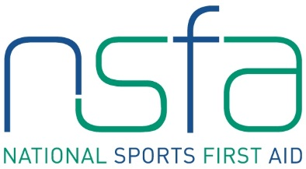

Sports First Aid Registration Form

Hampden Park – Sunday 28th April, Saturday 18th May, Sunday 16th June, Saturday 13th July, Sunday 25th August

Sunday 28th April 2019, Saturday 18th May 2019, Sunday 16th June 2019

BLOCK CAPITALS PLEASE

Name
(Including title)
Address

Post Code
Contact Numbers | Home:  Business:  Mobile:
E-mail Address
Date of Birth
Occupation
Sport

Position
e.g. coach, player

Level
e.g. club, national

Club Name

Previous First Aid Knowledge

Credit/debit card details

Card number _ _ _ _ _ _ _ _ _ _ _ _ _ _ _ _ _ _ _
Valid From _ _ / _ _ Expiry Date _ _ / _ _
Issue Number (if applicable) _ _ _
Validation Code _ _ _ (last three digits on security strip on back of card)

Signature Date

Please complete and return with your course fee of £75.00 to
Kirsty McDonald, NSFA Administrator, Hampden Sports Clinic, Hampden Park, Glasgow, G42 9ED.
Please make cheque payable to “NSSMC”.
Email: nsfa@hampdensportsclinic.com

