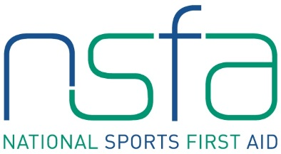

Sports First Aid Registration Form

Hampden Park – Sunday 24th February, Saturday 23rd March,

Sunday 28th April, Saturday 18th May, Sunday 16th June
Saturday 30th March – Robert Gordon University (Aberdeen)
Elgin City FC – Sunday 7th April 2019

BLOCK CAPITALS PLEASE

Name
(Including title)
Address

Post Code
Contact Numbers | Home:  Business:  Mobile:
E-mail Address
Date of Birth
Occupation
Sport

Position
e.g. coach, player

Level
e.g. club, national

Club Name

Previous First Aid Knowledge

Credit/debit card details

Card number _ _ _ _ _ _ _ _ _ _ _ _ _ _ _ _ _ _ _
Valid From _ _ / _ _ Expiry Date _ _ / _ _
Issue Number (if applicable) _ _ _
Validation Code _ _ _ (last three digits on security strip on back of card)

Signature Date

Please complete and return with your course fee of £75.00 to
Kirsty McDonald, NSFA Administrator, Hampden Sports Clinic, Hampden Park, Glasgow, G42 9ED.
Please make cheque payable to “NSSMC”.
Email: nsfa@hampdensportsclinic.com

