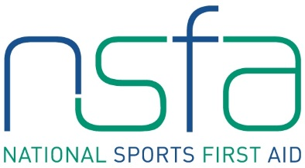

Sports First Aid Registration Form

Hampden Park –Saturday 3rd November, Sunday 25th November, Saturday 19th January

Sunday 24th February, Saturday 23rd March, Sunday 28th April, Saturday 18th May, Sunday 16th June
Aberdeen Football Club (Pittodrie Stadium) – Saturday 12th January 2019

BLOCK CAPITALS PLEASE

Name
(Including title)
Address

Post Code
Contact Numbers | Home:  Business:  Mobile:
E-mail Address
Date of Birth
Occupation
Sport

Position
e.g. coach, player

Level
e.g. club, national

Club Name

Previous First Aid Knowledge

Credit/debit card details

Card number _ _ _ _ _ _ _ _ _ _ _ _ _ _ _ _ _ _ _
Valid From _ _ / _ _ Expiry Date _ _ / _ _
Issue Number (if applicable) _ _ _
Validation Code _ _ _ (last three digits on security strip on back of card)

Signature Date

Please complete and return with your course fee of £75.00 to
Kirsty McDonald, NSFA Administrator, Hampden Sports Clinic, Hampden Park, Glasgow, G42 9ED.
Please make cheque payable to “NSSMC”.
Email: nsfa@hampdensportsclinic.com

