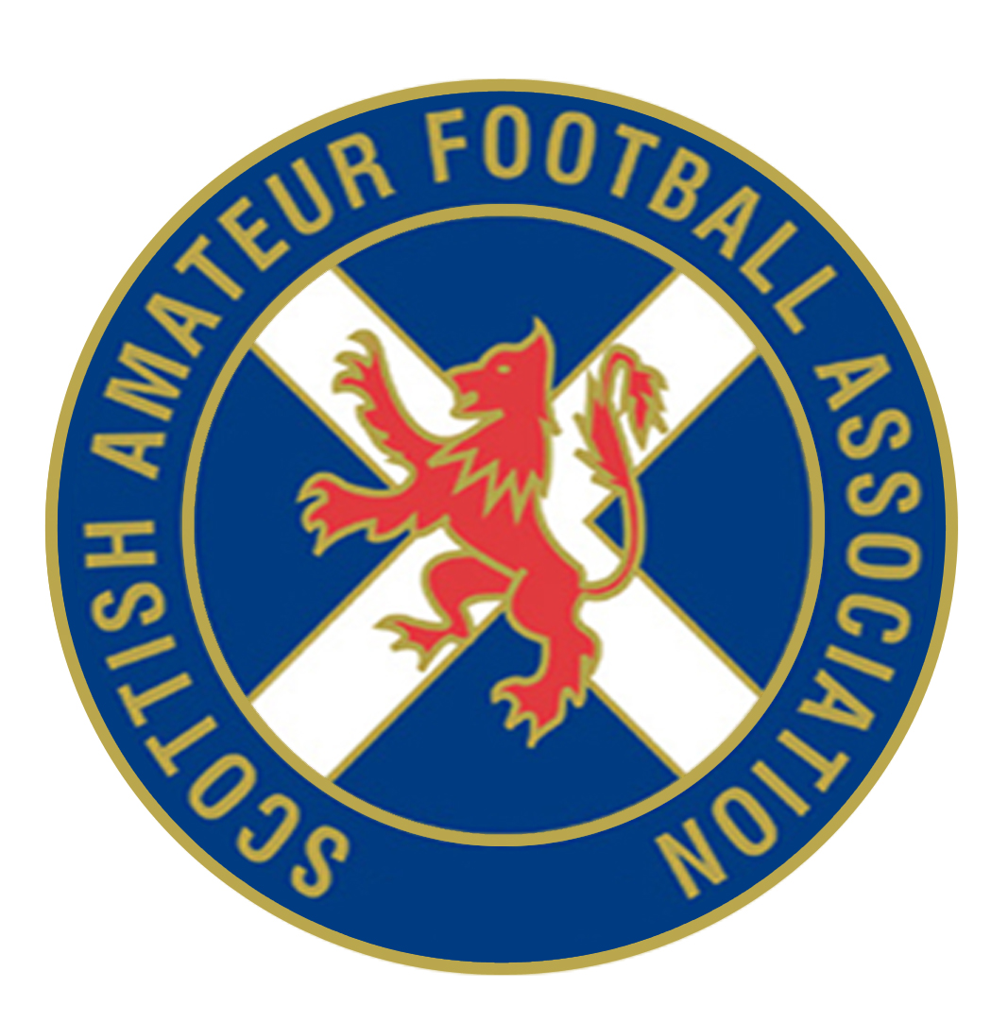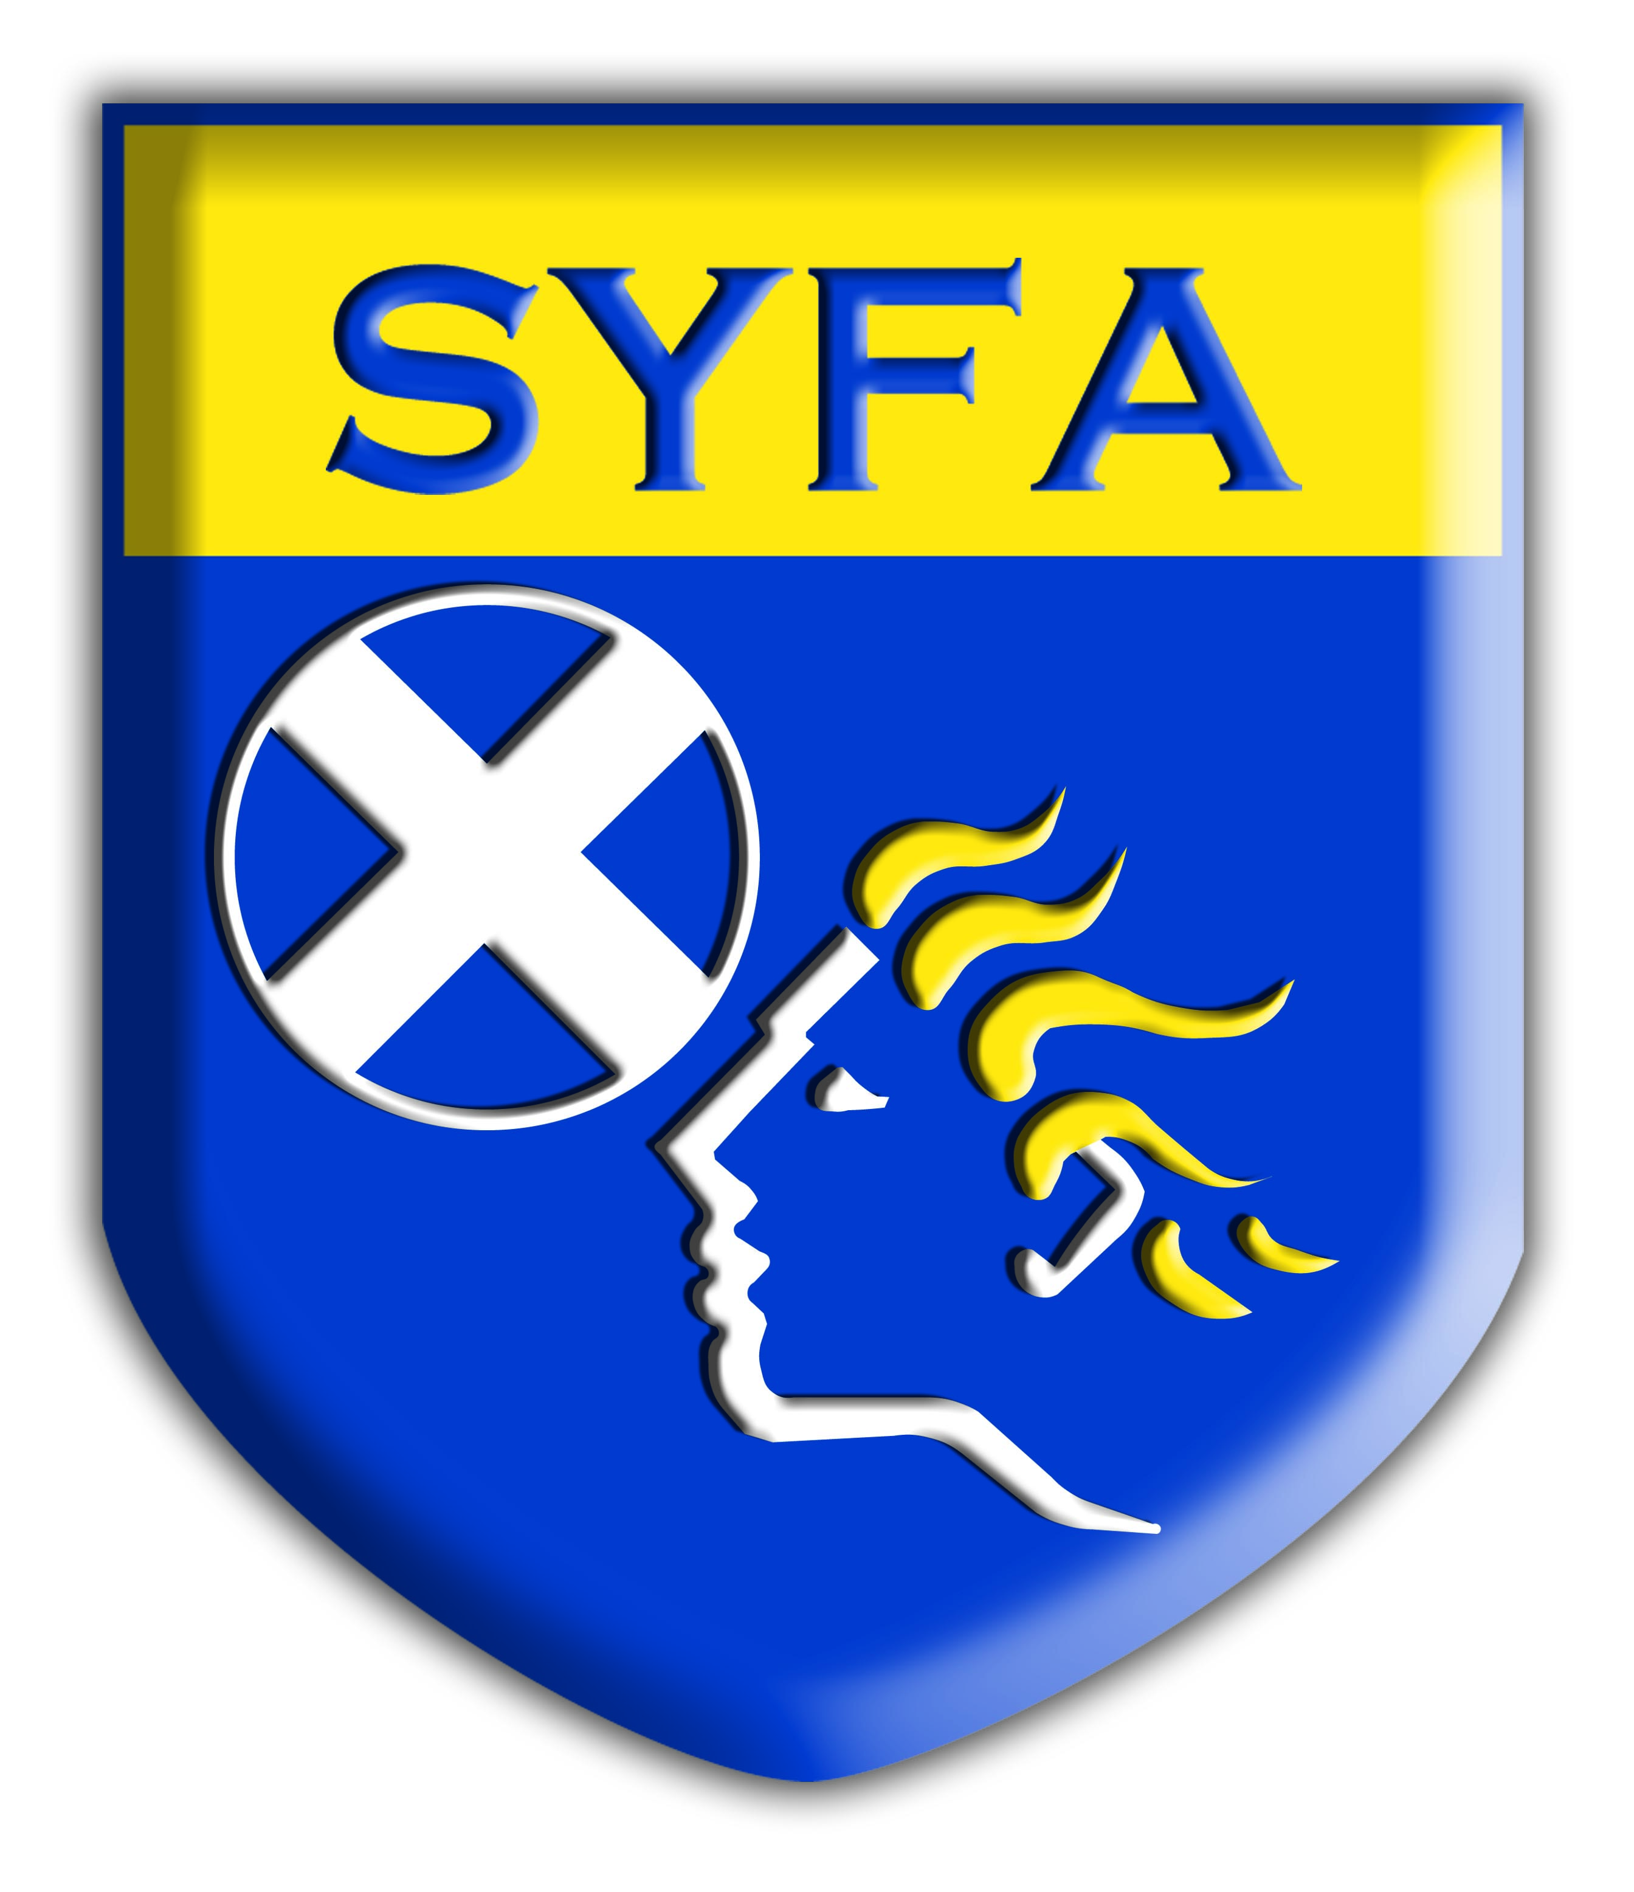

AGREEMENT BETWEEN THE SCOTTISH AMATEUR FA

AND THE SCOTTISH YOUTH FA (EXTRACT)

- The parties to this agreement shall be the Scottish Amateur FA (SAFA) and the Scottish Youth FA (SYFA).

- This agreement will be binding on member clubs as follows:
Scottish Amateur FA member clubs participating in Sunday leagues; and
Scottish Youth FA member clubs participating at age group 21.

- Any communications between member clubs of both Associations must only be carried out by the registered secretary of the said clubs.

- It is agreed that the SYFA will solely organise football for clubs and leagues at age group 21.

- A player from an SYFA member club participating at age group 21’s may also play for an SAFA member club who participate within a league who organise Sunday football. Players will register in accordance with SYFA registration procedures and record their participation within SAFA with the relevant match secretary for that club.

- A player from an SAFA member club who participate within a league who organise Sunday football may also play for an SYFA member club who participate within a league who organise football at age group 21’s. Players will register in accordance with SAFA registration procedures and record their participation within the SYFA with the relevant match secretary for that club.

- Players will register in accordance with the relevant procedure for that club.

- In the event of a clash of fixtures and no agreement between the two clubs in respect of which club the player should play for then the player will play for the club for whom he first registered.

9. All cases of contravention of this agreement shall be reported to the Association concerned.

Agreed on behalf of the Scottish Amateur FA Agreed on behalf of the Scottish Youth FA

