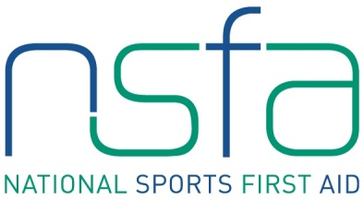

The National Sports First Aid Course

ABERDEEN
Robert Gordon University

Registration Form

2016 Course Dates (Please tick preferred date. Places will be allocated on a first come, first served basis)

Saturday 25th & Sunday 26th June 2016

PLEASE COMPLETE IN BLOCK CAPITALS.

Name
(Including title)
Address

Post Code
Contact Numbers | Home:  Business:  Mobile:
E-mail Address
Date of Birth
Position | Football Club First Aider

Club Name

League/Association
Association | Scottish Amateur FA

If you are allocated a place on a course and you accept the place, should you fail to attend or send an alternative SAFA member then the full course fee of £95 will be levied against your SAFA club.

Signature Date

Please complete and return to SAFA@scottish-football.com

