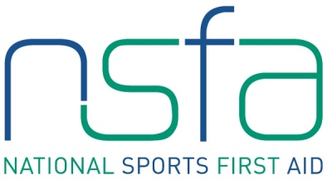
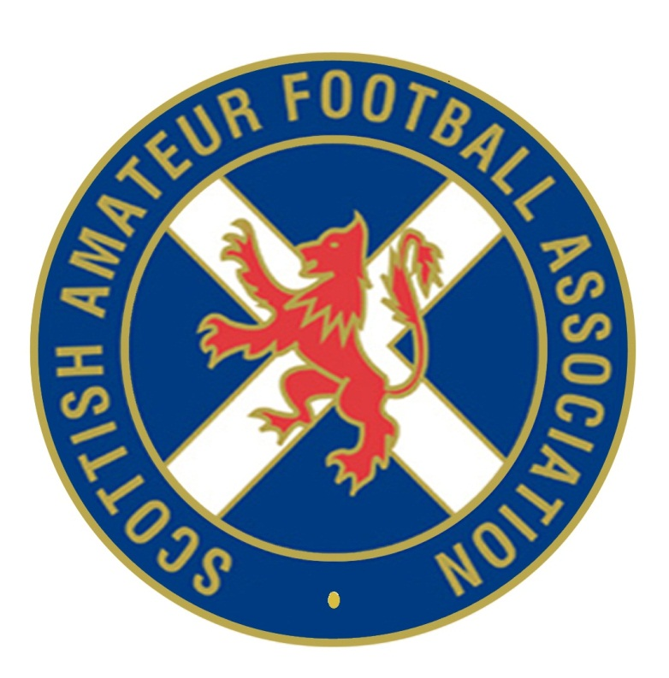

The National Sports First Aid Course

Aberdeen
Balgonie Bowling Club
Scotstown Gardens
Bridge of Don
Aberdeen
AB23 8HX

Registration Form

2015 Course Dates (Please tick preferred date. Places will be allocated on a first come, first served basis)

Saturday 24th & Sunday 25th October 2015

PLEASE COMPLETE IN BLOCK CAPITALS.

Name
(Including title)
Address

Post Code
Contact Numbers | Home:  Business:  Mobile:
E-mail Address
Date of Birth
Position | Football Club First Aider

Club Name

League/Association
Association | Scottish Amateur FA

If you are allocated a place on a course and you accept the place, should you fail to attend or send an alternative SAFA member then the full course fee of £95 will be levied against your SAFA club.

Signature Date

Please complete and return to SAFA@scottish-football.com

