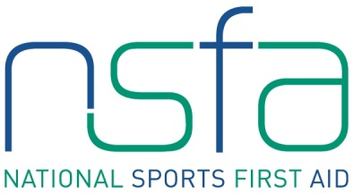
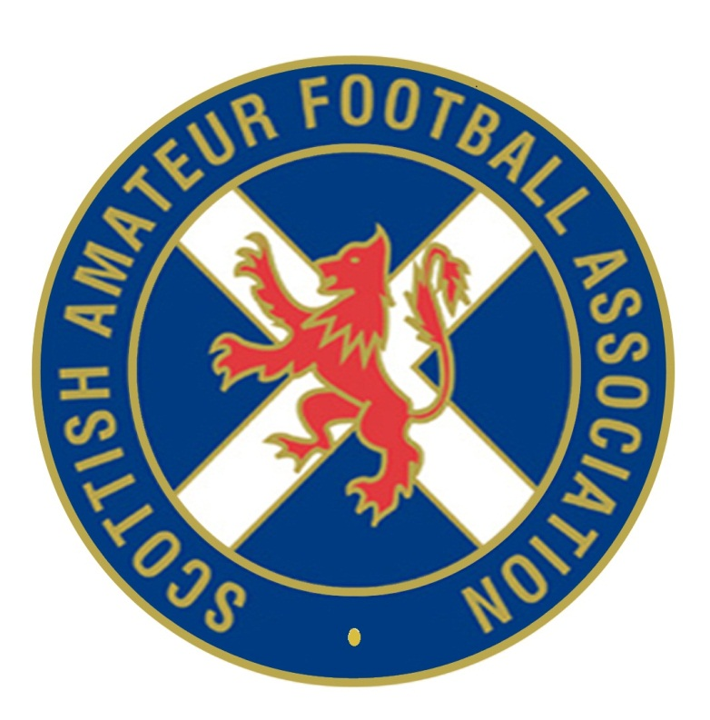

The National Sports First Aid Course

Hampden Park, Glasgow

Registration Form

2015 Course Dates (Please tick preferred date. Places will be allocated on a first come, first served basis)

Saturday 23rd & Sunday 24th May 2015
Saturday 27th & Sunday 28th June 2015
Saturday 25th & Sunday 26th July 2015
Saturday 22nd & Sunday 23rd August 2015

(All above courses at Hampden Park, Glasgow)
PLEASE COMPLETE IN BLOCK CAPITALS.

Name
(Including title)
Address

Post Code
Contact Numbers | Home:  Business:  Mobile:
E-mail Address
Date of Birth
Position | Football Club First Aider

Club Name

League/Association
Association | Scottish Amateur FA

If you are allocated a place on a course and you accept the place, should you fail to attend or send an alternative SAFA member then the full course fee of £95 will be levied against your SAFA club.

Signature Date

Please complete and return to SAFA@scottish-football.com

