COLVILLE PARK COUNTRY CLUB
WEST OF SCOTLAND AMATEUR CUP 2014
3rd ROUND ties:
RESULTS: SATURDAY 29TH november 2014
A
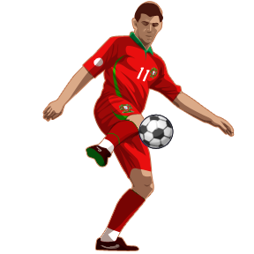
HOME |  |  | AWAY | 1.30pm
CRAIGIE | 0 | 3 | DENNISTOUN VALE
DRUMCHAPEL A.F.C. | 6 | 2 | SHORTLEES
DUMBARTON WANDERERS | 3 | 1 | MILL UNITED
HOUSTON | 1 | 0 | ST’DAVIDS
JAMESTOWN | 1 | 3 | DEAN
MOSSEND | 2 | 4 | DRUMCHAPEL UNITED
NEW FARM LOCH | 3 | 0 | OCHILTREE UNITED
Note : Outstanding
TIES: 3rd Round |  |  |  |  | Reason:
DIRRANS |  |  | POSTAL UNITED |  | Scottish Cup Tie
Pending
West Exec: Decisions
GLYNHILL MOORCROFT |  |  | REDBRAE
VICTORIA CROFTFOOT |  |  | BROOMHOUSE
MILTON |  |  | KSC WOLVES
FC EDDLEWOOD |  |  | SOUTHSIDE
FERGUSLIE STAR |  |  | CARDROSS

DENOTES: THIRD ATTEMPT TO PLAY THE TIE IF POSTPONED: TIE WILL BE REVERESED

