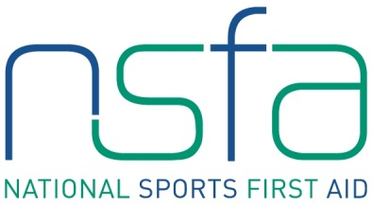
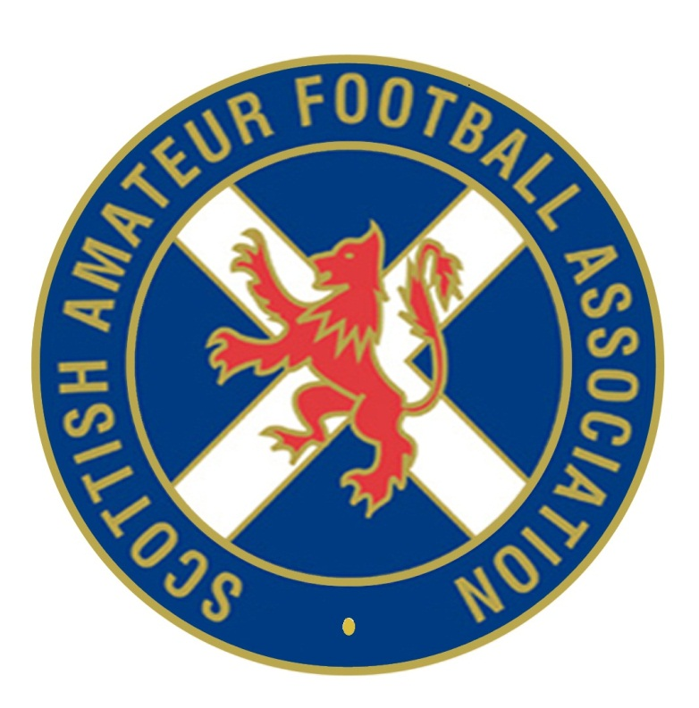

The National Sports First Aid Course

Hampden Park, Glasgow

Registration Form

2014 Course Dates (Please tick preferred date. Places will be allocated on a first come, first served basis)

Saturday 18th & Sunday 19th January 2014
Saturday 22nd & Sunday 23rd February 2014 Saturday 20th & Sunday 21st September 2014
Saturday 22nd & Sunday 23rd March 2014 Saturday 25th & Sunday 26th October 2014
Saturday 26th & Sunday 27th April 2014 Saturday 22nd & Sunday 23rd November 2014
Saturday 24th & Sunday 25th May 2014

Courses in June and July will be off-site due to 2014 Commonwealth Games. Details to follow.
PLEASE COMPLETE IN BLOCK CAPITALS.

Name
(Including title)
Address

Post Code
Contact Numbers | Home:  Business:  Mobile:
E-mail Address
Date of Birth
Position | Football Club First Aider

Club Name

League/Association
Association | Scottish Amateur FA

If you are allocated a place on a course and you accept the place, should you fail to attend or send an alternative SAFA member then the full course fee of £95 will be levied against your SAFA club.

Signature Date

Please complete and return to SAFA@scottish-football.com

