

Scottish Amateur Football Association | Wasp Solutions Ltd.

Scottish Amateur Football Association
Customer Requirements Specification
For Development
Association level OctSport Install and tailoring

Document Title: Association level OctSport Install and tailoring

Document Code: SAFACRS001

Version: 1.0

Effective Date: 20/06/12

Wasp Authorisation
Name: | Warren Dowey
Position: | Managing Director
Date: | 20/06/12
Signature:

Company Authorisation
Name: | Martin Bell
Position: | National Secretary
Date:
Signature:

Table of Contents
I. Copyright 5
II. Document control 6
III. Amendment history 6
IV. Distribution 7
V. Section One: Introduction 9
1.1 Purpose 9
1.2 Scope 9
1.3 References 9
1.4 Definitions and acronyms 9
VI. Section Two: Current Business Practice 12
2.1 Current Process/Operating Environment 12
2.2 How Application Software Works in the Process 12
2.3 Roles/Interactions Involved 12
2.4 Current/ Volumes 13
2.5 Frequency/Timings 13
2.6 Limitations 13
VII. Section Three: Proposed Business Practice 15
3.1 Proposed Process/Operating Environment 15
3.2 Roles/Interactions Involved 15
3.3 Proposed Volumes 16
3.4 Frequencies and timings 16
3.5 Benefits 16
VIII. Section Four: General Requirements 18
4.1 SYSTEM Design Requirements 18
4.1.1 Regions 18
4.2 General Requirements 18
IX. Additional man hours required 22

Copyright
Wasp Solutions Ltd. retains ownership of this document along with the methodology or format used to derive this document. This document must be treated as confidential, as disclosure of this document will disclose the methodology. This document can be used and copied within the Scottish Amateur Football Association for use in relation to this project. However, no copies can be forwarded to any person who is not an employee or agent of the Scottish Amateur Football Association without the prior written approval of Wasp Solutions Ltd. and after having received a signed non-disclosure agreement from any such person or agent.

Document control

This document is deemed to be controlled only as long as the project to which it relates is active. Controlled copies will be automatically updated.

Once the project is completed or terminated, this document must be destroyed by the Scottish Amateur Football Association although a copy will be held on record by Wasp Solutions Ltd. for future reference.

Amendment history
Amendment number | Updated by (signature)

Distribution

Controlled copies of this CRS will be distributed to each of the people specified below. These copies will be updated automatically as changes are made.

Title | Name | Copy #
Managing Director – Wasp Solutions Ltd. | Warren Dowey | 1
Account Director – Wasp Solutions Ltd. | Michaela Dowey | 2
National Secretary - Scottish Amateur Football Association | Martin Bell | 3

Uncontrolled copies will be initially distributed to the following people for comment and so they have an awareness of the project. They should refer to one of the above controlled copies on an ongoing basis.

Title | Person
PHP Programmer | Steven Craig
Designer | Stef Mason
Designer | Andrew Stewart
PHP Programmer | Robert McParland
PHP Programmer | Alex Wilde

Section One
Introduction

Section One: Introduction

1.1 Purpose
The purpose of this document is to provide a statement of requirements for a Customer Management System and website as described and requested by the Scottish Amateur Football Association.

1.2 Scope
The scope of this document is to layout the Customer Requirements and the development of a Functional Specification prior to Web development. We have taken into account current practices of development on the net both adopted by ourselves and by competitive companies. The Customer Requirements have been considered, their likes, dislikes, abilities, reference websites that they have considered, their current logo, colour scheme and that of their suppliers.

1.3 References
www.thenafl.co.uk

1.4 Definitions and acronyms

Acronym | Meaning
CRS | Customer Requirements Specification
FS | Functional Specification
COTS | Commercial Off The Shelf
GUI | Graphical User Interface
IPN | Instant Payment Notification
API | Application Programmable Interface
CRON | Chronological job performed at regular intervals on the server
RMA | Return Merchandise Authorization
W3C | World Wide Web Consortium
XHTML | Extensible Hypertext Mark Up Language
XML | Extensible Mark up Language
SQL | Structured Query Language
ALT | Alternative text
CSV | Comma Separated Value
SEO/SEF | Search Engine Optomisation / Search Engine Friendly
SAFA | Scottish Amateur Football Association

Section Two
Current Business Practices

Section Two: Current Business Practice

Currently the observations of the SAFA site are limited as much of the control of the site is based on the controls imposed by the main SFA site

2.1 Current Process/Operating Environment
The site is currently running cfm cold fusion scripts to deliver it’s content to the end user, and limits the administrator to dynamically generated standard html and flash based pages
There is no serious business model in terms of structured content or further dynamic nature.
Although unsure of the platform that the cfm scripts run on it must be noted that on numerous occasions outages of the site were noted. Partial outages were also noted such that the browser on instances failed to deliver the page due to speeds of either the server or the generation of the page. This is further noted by Alexa’s reporting that the site is very slow and 83% of sites are faster.
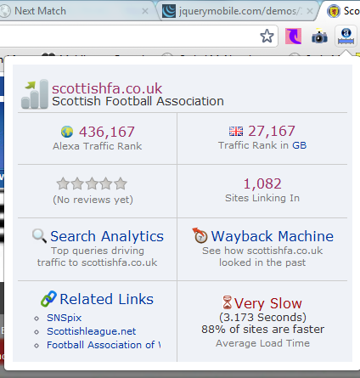
Currently offline SAFA have a major task each year to organise Cup matches and knock out based competitions. These competitions involve over 60 amateur leagues and 4000 teams. On top of the task of the organisation of such, the collation of the results and the display of such is a major task in itself.
Other chores of SAFA include the very upkeep of the management of the information held on the teams, leagues, players and referees within

2.2 How Application Software Works in the Process
Currently their web application has no bearing on the management of their information

2.3 Roles/Interactions Involved
The main core team of SAFA consists of a team of three involved with the management of the information and the updating of their website.
Interactions with the website and the data update and display to external entities is limited only to the display of set text and images to visitors to their website and does not allow any advanced control.

2.4 Current/ Volumes
There is currently only one version of their website based as a sub site within the main Scottish FA website.

2.5 Frequency/Timings
Frequency of updates of information should be on a daily / weekly basis for news items and the frequency of update of information around cup season being very intensive with updates being required from approximately 2000 match results a week/weekend

2.6 Limitations
Currently the controls of the cup competitions are very imposing and require a lot of man hours to collate and manage without the data being contained in a manageable format that can be easily displayed to visitors to their site. Management of the leagues, teams and referees is also not performed in such a way that facilitates easy management, updating, displaying online or making use of the data in a way that is commercially viable.
Currently SAFA has no methodology for collecting or updating information on league results for the leagues contained within it.

Section Three
Proposed Business Practice

Section Three: Proposed Business Practice

3.1 Proposed Process/Operating Environment
It is proposed that a fully functional enabled website is developed and hosted in a separate location to remove the constraints of upkeep of a web server. The site should enable the admin to control page content, results, news, clubs, leagues, referees contact and site details, newsletter, regions, seasons. This needs to be in a user friendly GUI and based on our Association level OctSport.
It is expected that Wasp Solutions Ltd. should facilitate the initial insert of a few sample clubs / leagues, fixtures and results whilst demonstrating the usage of the system.

3.2 Roles/Interactions Involved
Three main categories of interaction site member, standard visitor and admin.
The site members will be set by the site admin and will be members who are responsible for a league giving them the ability to control the data held about their league.
Admin staff will be responsible for editing static pages, adding and editing news, clubs, divisions, leagues, seasons, regions and the teams involved in each region.
Each time before a cup is commenced each season the SAFA admin will set which teams play each other at group stage at each region.
The cup management system will automatically calculate the number of matches required for each cup, the number of byes and the admin will set which winners will play against each other.
After each cup match is played an automated SMS will be sent asking the (Club secretary of each playing home team) or (referee at each match) (dependant on site configuration set by admin) to update the result of the match. When the receiver replies with an SMS it will update the cup results and adjust which teams play next until the cup is completed.
This will be intrinsically safe such that no others will be able to adjust the results by SMS and the system will handle invalid SMS messages gracefully
We will provide an automated system whereby any league that runs the OctSport league level system will post it’s data to the SAFA site automatically and require no further maintenance on the part of the SAFA admin, for that league or the clubs and divisions contained within.
The admin section will provide the facility edit or add cup results where necessary although for the majority this should be an automated process.
Addition of leagues divisions and teams will be further facilitated by bulk addition using CSV upload.
Admin staff may occasionally check and edit site configuration.
An automated Cron job should run to send newsletters, request cup results using SMS facility.
Non-members should be able to browse the site and partake of all site functionality with the exception of Account Management.
Non-members may also sign up for a SAFA newsletter to keep them updated with news and results.
Further benefit will be realised by automated collection of league results, tables and upcoming fixtures from each league website running OctLeague.

3.3 Proposed Volumes
There should be 1 version of the site complete in its entirety at first release, although the system will be modular to allow for easy addition of extra features and modules as well as easy maintenance, this should be further enhanced with the inclusion of the template module allowing for easy change of graphics and css when the site would require a facelift or change of design in a few years to keep interest of it’s followers.

3.4 Frequencies and timings
Release of the site will be in August prior to the start of the cups although the facility to receive results, fixtures and tables will facilitate leagues to adopt the OctLeague system at any time.

3.5 Benefits
SAFA will benefit from a web application that is extremely automated and controls their data in a more efficient business manner. The site due to its automated manner will be extremely dynamic and very SEO when combined with this fact and due to the nature of the high standard of PHP and HTML adopted.
The application will greatly reduce costs involved with the task of managing the cups and collating data and add additional information that is not currently being taken advantage of.
Presentation of the data to site visitors will ensure that the SAFA site will become the hub of all information regarding any Scottish Amateur football.

Section Four
General Requirements

Section Four: General Requirements

SYSTEM Design Requirements
As per our OctAssociation with additional specific requirements noted

Regions
      - This will allow for the addition or subtraction of regions.
    - Region teams
      - This will allow teams to be associated with a region
    - Team bulk upload
      - Upload of teams using csv file
    - Division bulk upload
      - Upload of teams using csv file
    - Region cups
      - The admin will set which regions are involved in each cup
      - This will affect the teams that can be set for matches within a cup
    - Group stage on cups
      - Each cup when created will have a “has group stage” set on it
      - If a cup has a group stage then when setting the cup matches in Bulk Cup Matches there will be additional group stage matches to fill in.
      - The winners of group stage will automatically fall into the round stages of the cup that they are in

General Requirements
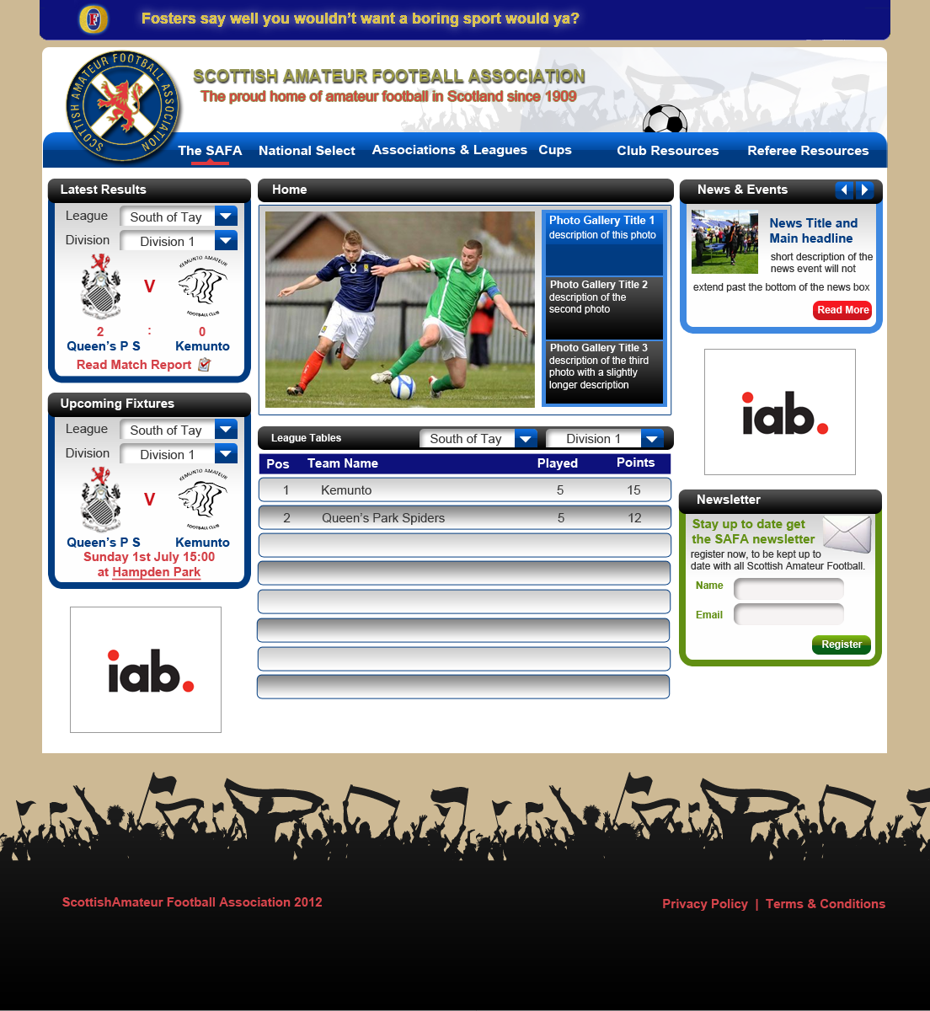
    - Proposed layout design

    - All entry forms on the site must have SQL Injection prevention.
    - All entry boxes must prevent hijacking by javascript, vbscript, DHTML, server side includes and any other scripting technique.
    - Forms must prevent hijacking by TamperData.
    - All images must have Alts.
    - All Hyperlinks must have titles.
    - All pages will contain dynamic meta tags.
    - The site will be W3C XHTML compliant.
    - The site will have a robots.txt file.
    - The site will have an automatically updated sitemap
    - The site will have an automatically created dynamic Google sitemap in XML.
    - The site should display a padlock logo on SSL encrypted pages.
    - All encrypted pages should be tested so that there are no error messages and breaches of SSL
    - For each layout the admin should be able to edit its CSS.
    - The site configuration should allow for the switching on of Gzip compression and setting of the level.
    - The code for the site should be well laid out and well commented with good variable naming convention for ease of maintenance and future enhancement.
    - The admin and front-end layout should be template based and the default layout should be non-cluttered with dropdown menus and a clean colour scheme. The admin layout should be based on our current control panel layout.
    - The site should prevent bandwidth hijacking
    - Blowfish encryption should be used on passwords
    - Login and registration pages should use SSL encryption.
    - No un-necessary code should be present.

Section Five
Estimated Tailoring Costs & Duration

Additional man hours required
120 additional man hours would be required for development of the additional requirements, this would be on top of the allotted man hours included in the purchasing and set up of OctAssociation and development of the site design and layout
This equates to 15 additional days at a rate of £610 per day for a lead PHP developer but due to the number of hours required we can supply the development at our contractual rate supplied to clients on long term lease at £360 per day.
Thus additional costs required £5400

